Full Adder :-
A combinational circuit that performs the addition of three bits at a time is called full adder. It consists of three inputs and two outputs , two inputs are the bits to be added , the third input represents the carry from the previous position.
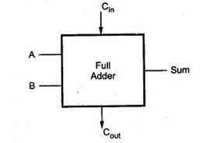

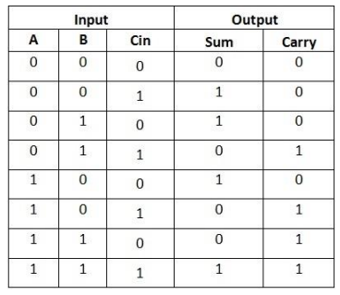
Fig. :- Block diagram

Truth table :-

